# Project: Summarizing and Analyzing Research Papers

## Submission Template

**Learner Name**: YASH KAPOOR

**Learner Email**: [yashkapoor959@gmail.com](mailto:yashkapoor959@gmail.com)

**Topic**: Summarize and analyze research on cognitive-behavioral therapy for anxiety disorders

**Research Paper**: [Efficacy of Cognitive Behavioral Therapy for Anxiety Disorders: A Review of Meta-Analytic Findings](https://citeseerx.ist.psu.edu/document?repid=rep1&type=pdf&doi=f38bcd45c4c28dad099493a3ea37f030d1b48267)

### Initial Prompt

**Description (50 words max)**: Explain the research paper purpose and highlight the important topics included in this research paper. (In Maximum of 100 words)

**Generated Summary (100 words max)**: The research paper aims to synthesize meta-analytic findings on the efficacy of Cognitive Behavioral Therapy (CBT) for anxiety disorders, establishing its effectiveness compared to other treatments. Important topics include the prevalence and impact of anxiety disorders, mechanisms underlying these conditions, the effectiveness of CBT, comparisons with other therapeutic approaches, the durability of treatment effects, and the debate over combined therapeutic methods. The paper also discusses future directions for enhancing CBT's efficacy and explores potential augmentations with pharmacotherapy to improve treatment outcomes.

### Iteration 1

**Description (50 words max)**: a flowchart that outlines the key components related to the effectiveness of Cognitive Behavioral Therapy (CBT) for anxiety disorders based on the findings from the research paper. (In 100 words)

**Generated Summary (100 words max)**: Here's a concise flowchart outlining the key components related to the effectiveness of Cognitive Behavioral Therapy (CBT) for anxiety disorders:

[Start]

|

v

[Prevalence of Anxiety Disorders]

|

v

[Impact on Quality of Life]

|

v

[Mechanisms of Anxiety]

|

v

[Effectiveness of CBT]

|

v

[Comparison with Other Treatments]

|--------------------------------|

| |

v v

[CBT More Effective] [CBT Not 100% Effective]

| |

v v

[Durability Concerns] [Need for Augmentation]

|

v

[Future Research Directions]

|

v

[End]

This flowchart summarizes the main findings and discussions regarding CBT's effectiveness for anxiety disorders.

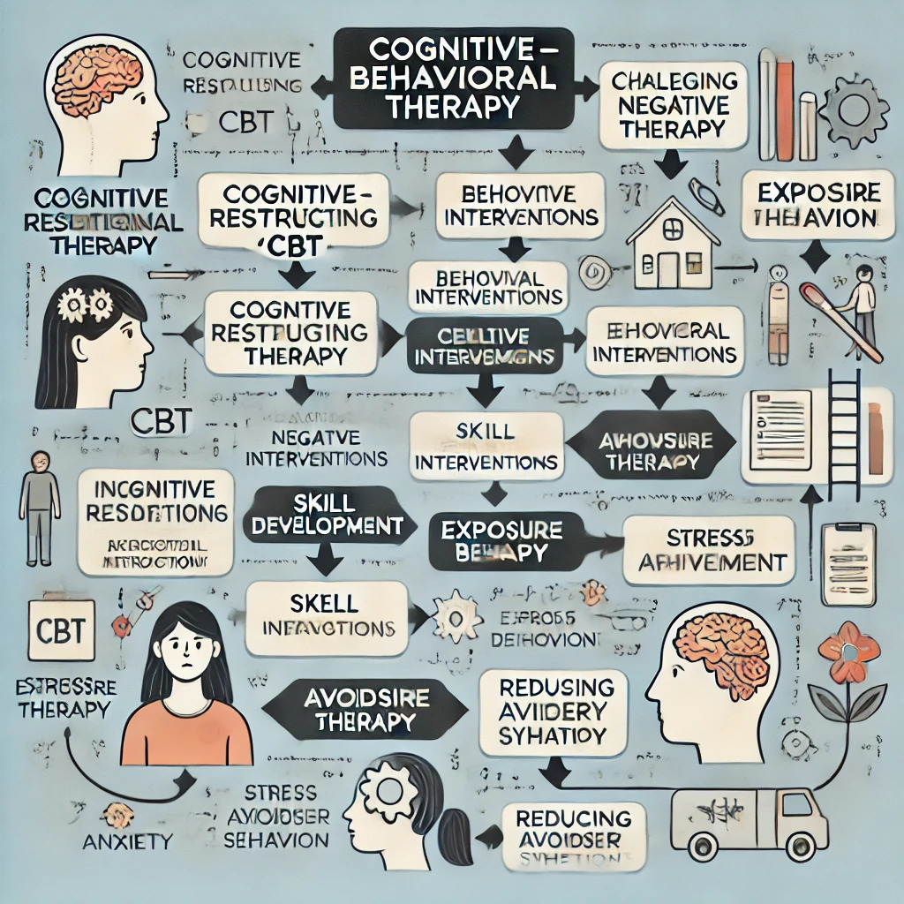

### Iteration 2

**Description (50 words max)**: What research methods were used to study the mechanisms underlying anxiety disorders?

**Generated Summary (100 words max)**: The research methods used to study the mechanisms underlying anxiety disorders include:

1. **Descriptive Research**: Characterizes symptoms and behaviors associated with anxiety.

2. **Experimental Research**: Tests specific hypotheses regarding cognitive biases and avoidance behaviors.

3. **Information-Processing Studies**: Examines attentional biases toward threat-related stimuli in individuals with anxiety.

4. **Meta-Analytic Reviews**: Synthesizes findings from multiple studies to evaluate treatment effectiveness and identify mechanisms of change.

5. **Randomized Controlled Trials**: Assesses the efficacy of interventions like Cognitive Behavioral Therapy (CBT) in reducing anxiety symptoms.

These methods collectively enhance understanding of the factors contributing to anxiety disorders.

### Final Prompt

**Description (50 words max)**: Conclude the summary of this paper in a clear and concise manner which could be easily understood by students.

**Generated Summary (100 words max)**: Cognitive Behavioral Therapy (CBT) is a highly effective treatment for anxiety disorders, helping individuals identify and challenge negative thought patterns and behaviors that contribute to anxiety. The therapy focuses on cognitive restructuring, behavioral interventions, and skill development, leading to significant reductions in anxiety symptoms. CBT is well-supported by research and has been shown to provide lasting benefits, even after therapy ends. Though challenges like treatment adherence and access exist, CBT remains a widely recommended approach for managing anxiety, offering patients practical tools to maintain mental well-being long-term.

### Insights and Applications

**Key Insights (150 words max)**:

* CBT effectively reduces anxiety by addressing and restructuring negative thought patterns.
* Behavioral interventions, such as exposure therapy, play a crucial role in diminishing avoidance behaviors and fear responses.
* CBT equips patients with coping skills like stress management and problem-solving, which contribute to long-term symptom reduction.
* Research consistently shows CBT is as effective, if not more so, than other treatments, including medication.
* The durability of CBT’s effects and its focus on relapse prevention are significant strengths.
* Challenges include ensuring patient adherence and improving access to CBT services.

**Potential Applications (150 words max)**:

* Integrating CBT into school curricula to help students manage anxiety and develop coping strategies.
* Expanding teletherapy platforms to make CBT more accessible to those in remote or underserved areas.
* Combining CBT with pharmacotherapy for more effective treatment of severe anxiety disorders.
* Using CBT principles in workplace wellness programs to reduce stress and improve employee mental health.
* Developing self-guided CBT modules to empower individuals to manage anxiety independently.
* Personalizing CBT approaches to cater to specific patient needs, enhancing treatment effectiveness.

### Evaluation

**Clarity (50 words max)**: The final summary and insights are clear, concise, and accessible to students, effectively conveying the core concepts of CBT and its applications in treating anxiety disorders. The language used is straightforward, ensuring that the key points are easily understood without oversimplifying the content.

**Accuracy (50 words max)**: The final summary accurately reflects the research paper's findings, capturing the essential elements of CBT's effectiveness in treating anxiety disorders. The insights provided are consistent with the paper's conclusions, ensuring that the information presented is both reliable and well-aligned with the original research.

**Relevance (50 words max)**: The insights and applications discussed are highly relevant to both clinical practice and broader contexts like education and workplace mental health initiatives. The relevance extends to the potential integration of digital CBT platforms, which align with current trends in telemedicine and remote therapy, making the findings applicable in modern healthcare settings.

### Reflection

**(250 words max)**: During my internship, I delved into the field of Generative AI, working with tools like ChatGPT, DALL-E, Perplexity, and Microsoft Copilot. I explored essential concepts such as GANs, VAEs, ML, and NLP, and gained hands-on experience with Prompt Engineering. One key challenge was understanding and addressing the limitations, biases, and privacy concerns associated with these technologies, which required careful analysis and adaptation. A significant insight was the practical application of Generative AI in marketing, exemplified by how brands like Coca-Cola, Heinz, Nike, Nutella, and Netflix utilize these tools to enhance their strategies. This practical exposure highlighted the transformative potential of AI in real-world scenarios. Additionally, working on a project that summarized and analyzed research papers on cognitive-behavioral therapy for anxiety disorders allowed me to apply AI insights to meaningful research, bridging theoretical knowledge with practical application. Overall, this internship enriched my understanding of Generative AI, equipped me with valuable skills, and provided practical insights that will inform my future endeavors in the field.